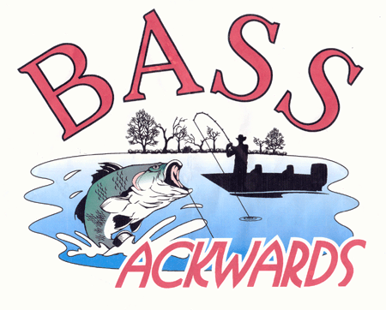

Tuesday, April 4, 2017
Website: http://www.bassackwards.org

Meeting Start: 7:00pm

Attendees:
X | Leo Boisvert | Bahrain | Shawn Myers | X | Robert Stamey
X | Perry Garner | X | Wade Norris |  | Richard Woods
X | Rick Gould | X | Dale Passarella |  | Tom Lane
 | Mike Jackson | X | Mike Polychroni |  | Tom Terrance
X | Daryl Johnson | X | Paul Saliga
 | Levi Kinchlow | X | Steve Simmons
X | Ken Kipler | X | Keith Tolarchyk
 | Pete Lorsong |  | Mike Vesely
 | Kevin Massie |  | Jason Westfall
X | Tom McMahan | X | Bill Whispell
X | Bill Murtha | X | Johnnie Wood

Treasury Report:

Given and accepted.

Previous Meeting Minutes:

Minutes read and accepted as read.

Old Business:

NA

New Business:

The club would like to welcome its newest Member, Tom Terrance, voted in by unanimous vote.

Draw was held for blastoff order during the Don Borsch Classic on Lake Gaston. Results to be posted on the club website.

A review of the March tournament held on the Chowan river was conducted.

A motion was made for the club to pay for food to support a Saturday night cookout during the Don Borsch classic. Not to exceed $200.00. 2nd and approved. Motion passed.

The tournament director for the Lake Chesdin tournament made a motion to change the date of the tournament from 15 October to 30 September. Question and discussion on the floor regarding if a tournament date change can be made after the schedule has been voted on and approved. It was determined that it is allowed as set forth in the current bilaws. A vote was taken to change the date of the tournament and the motion passed 13 to 4.

A change to the bilaws regarding modifying the tournament schedule was written and read for review at the April meeting. A motion was made to accept the bilaw change as written. The motion was 2nd. Discussion on the floor. The motion to accept was withdrawn. Motion was made to table the change until the December meeting. Motion was 2nd. Motion passed.

Notes:

Meeting Adjourned: 8:05pm

