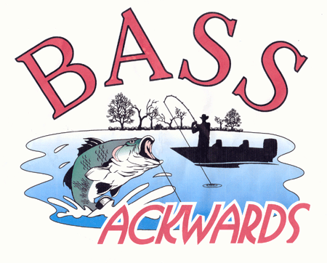

Tuesday, May 2, 2017
Website: http://www.bassackwards.org

Meeting Start: 7:00pm

Attendees:
 | Leo Boisvert | Bahrain | Shawn Myers
X | Perry Garner | X | Wade Norris |  | Richard Woods
X | Rick Gould | X | Dale Passarella | X | Tom Lane
 | Mike Jackson |  | Mike Polychroni |  | Tom Terrance
X | Daryl Johnson |  | Paul Saliga | X | Josh
 | Levi Kinchlow |  | Steve Simmons
 | Ken Kipler | X | Keith Tolarchyk
X | Pete Lorsong |  | Mike Vesely
X | Kevin Massie |  | Jason Westfall
X | Tom McMahan | X | Bill Whispell
X | Bill Murtha | X | Johnnie Wood

Treasury Report:

Given and accepted.

Previous Meeting Minutes:

Minutes read and accepted as read.

Old Business:

NA

New Business:

Review of the Don Borsch classic held on Lake Gaston.

Draw was held for blastoff order for the Perquimanns tournament on May 6. Results to be posted on the club website.

Draw was held for blastoff order for the Edenton tournament on May 21. Results to be posted on the club website.

Notes:

Meeting Adjourned: 7:25pm

